นายพีรณัฐ ธารทะเลทอง 550610530
Digital Image Processing (261453)
Computer Assignment 3
- คำนวณหาพื้นที่ส่วนรูปดอกไม้สีขาวของรูป Flower_Snack.pgm

หาภาพ object ด้วยการเบลอภาพ ด้วย Gaussian low-pass filter ที่ cutoff = 36 เพื่อให้แยกวัตถุได้ดีขึ้น ได้ดังรูป
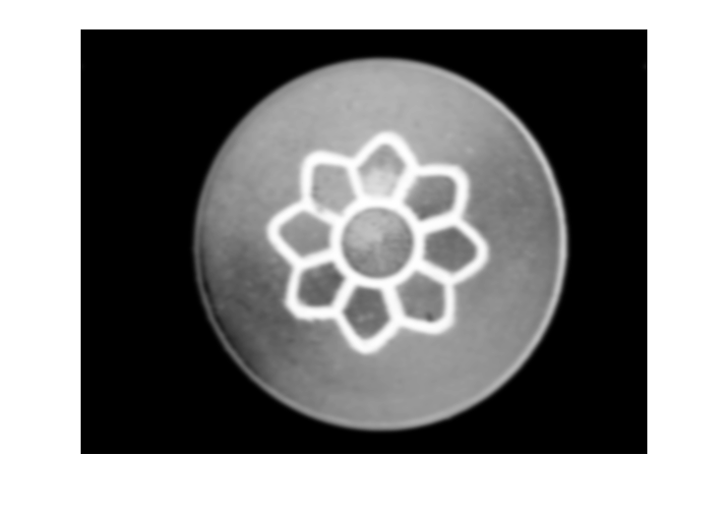

และตัด Threshold ที่ 225 เพื่อแยกวัตถุออกมา จะได้วัตถุดังรูป
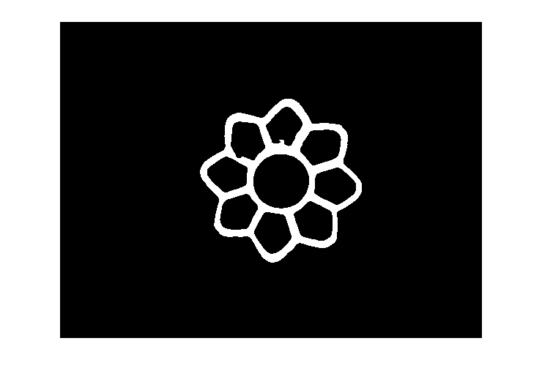

และหาวงกลมด้วยการลูปหาตำแหน่งที่ทำให้รัศมีมีค่ามากสุดและครอบพื้นที่วงกลมมากที่สุด
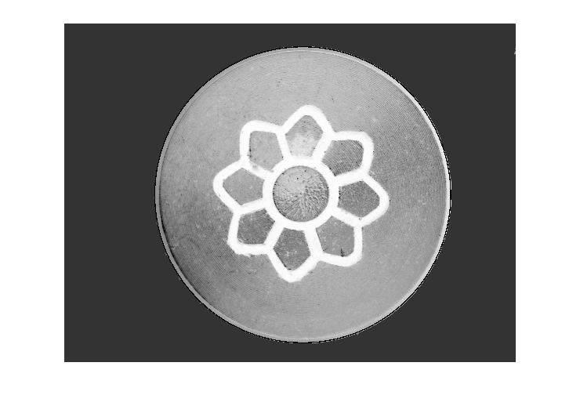
จะได้ ตำแหน่งที่ (1218, 875) และรัศมีขนาด 757 pixel และมาวาดเป็นขอบวงกลม (เส้นสีดำ) ดังรูป

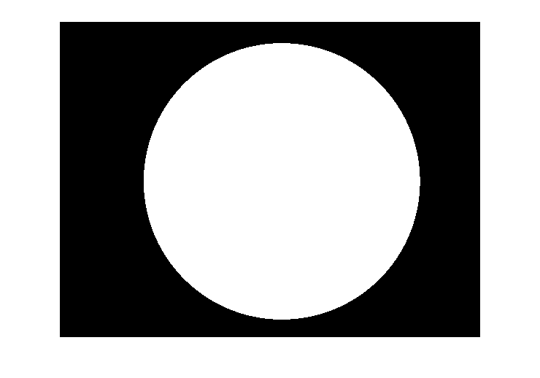
และวาดวงกลมด้วยตำแหน่งและรัศมีนั้น ได้ดังรูป

และหาจำนวน pixel ของทั้งสอง object และนำมาคำนวณหาพื้นได้ จะได้
Area = 2.6 * (195244 / 1785473) = 0.2843 cm²

- คำนวณหาพื้นที่ส่วนรูปปูของรูป Crab.pgm
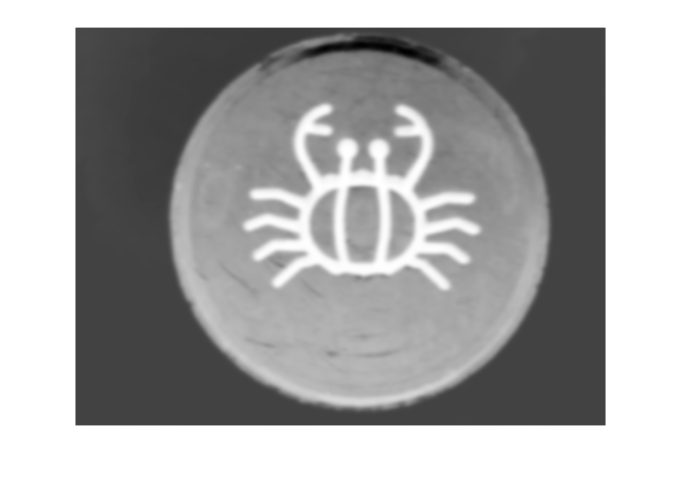
ใช้หลักการเดียวกันกับข้อแรก โดยการเบลอภาพ ด้วย Gaussian low-pass filter ที่ cutoff = 36 จะได้ดังรูป

และแยกวัตถุออกมา โดยตัด Threshold ที่ 215 จะได้วัตถุดังรูป
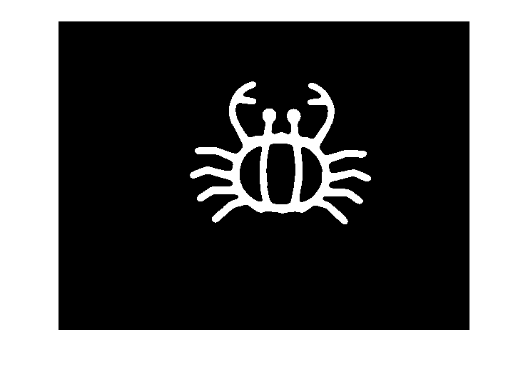

จากนั้นหาขอบของวงกลม จะได้ตำแหน่งที่ (1236, 847) รัศมีขนาด 820 pixel ซึ่งจะได้ขอบเส้นสีดำดังรูป
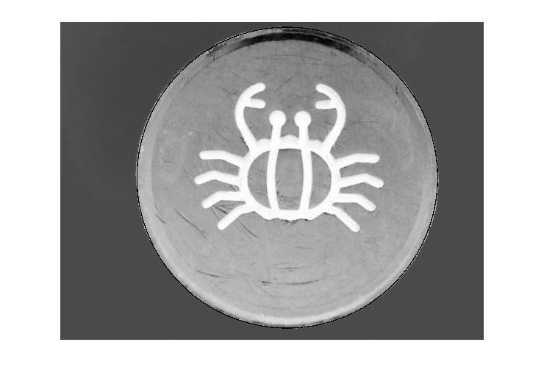
จะได้

ได้วงกลมที่ตำแหน่งและรัศมีนั้น ดังรูป
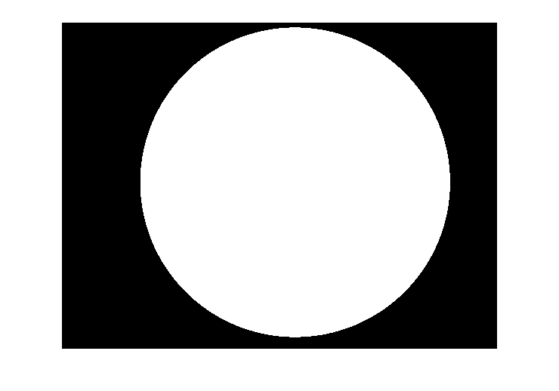

และหาจำนวน pixel ของทั้งสอง object และนำมาคำนวณหาพื้นได้ จะได้
Area = 2.766 * (228254/ 2092035) = 0.3018 cm²
Code (โค๊ดทั้งหมดอยู่ที่ https://github.com/porpeeranut/Digital_Image_Processing_Assignment3 )
Flower_Snack.m
flowerPath = 'Flower_Snack.pgm';
im = imread(flowerPath);
bgTH = 65;
flowTH = 210;
[h, w] = size(im)
bg = im;

% Gaussian Lowpass Filter
FFT = fftshift(fft2(im)); % shift to center
y = (w-1)/2;
x = (h-1)/2;
cutoff = 36;
[u,v] = meshgrid(-y:y,-x:x);
D = sqrt(u.^2+v.^2);
HG = double(exp((-(D).^2)./(2.*((cutoff).^2))));
% multiple wit fourier transform
GHG = HG.*FFT;
% inverse fourier transform
imObj = round(real(ifft2(ifftshift(GHG))));
figure('name','Gaussian Lowpass Filter');
imshow(real(imObj),[]);

% binary image to find obj
objPixel = 0;
TH = 225;
for i = 1:h
for j = 1:w
if (imObj(i,j) >= TH )
imObj(i,j) = 255;
objPixel = objPixel + 1;
else
imObj(i,j) = 0;
end
end
end
figure('name','obj');
imshow(imObj);

% black white bg
for r = 1:h
for c = 1:w
if (bg(r,c) > bgTH) && c < w-100
bg(r,c) = 255;
else
bg(r,c) = 140;
end
end
end

% find cycle
max = 0;
ansX = 0;
ansY = 0;
ansR = 0;
cycleIm = bg;
for x = 1190:1240
for y = 855:905
for r = 740:770
sum = 0;
for degree = 1:360
if (bg(y+round(r*sind(degree)), x+round(r*cosd(degree))) > 200)
sum = sum+1;
end
end
if (max < sum) && (ansR < r)
max = sum;
ansX = x;
ansY = y;
ansR = r;
end
end
end
end
max
ansX
ansY
ansR
max = 273;
ansX = 1218;
ansY = 875;
ansR = 757;

% set to black
for r = 1:h
for c = 1:w
cycleIm(r,c) = 0;
end
end

% show cycle border
for degree = 0:0.01:360
im(ansY+round(ansR*sind(degree)), ansX+round(ansR*cosd(degree))) = 0;
im(ansY+round((ansR-1)*sind(degree)), ansX+round((ansR-1)*cosd(degree))) = 0;
im(ansY+round((ansR-2)*sind(degree)), ansX+round((ansR-2)*cosd(degree))) = 0;
im(ansY+round((ansR-3)*sind(degree)), ansX+round((ansR-3)*cosd(degree))) = 0;
im(ansY+round((ansR-4)*sind(degree)), ansX+round((ansR-4)*cosd(degree))) = 0;

cycleIm(ansY+round(ansR*sind(degree)), ansX+round(ansR*cosd(degree))) = 255;
cycleIm(ansY+round((ansR-1)*sind(degree)), ansX+round((ansR-1)*cosd(degree))) = 255;
cycleIm(ansY+round((ansR-2)*sind(degree)), ansX+round((ansR-2)*cosd(degree))) = 255;
cycleIm(ansY+round((ansR-3)*sind(degree)), ansX+round((ansR-3)*cosd(degree))) = 255;
cycleIm(ansY+round((ansR-4)*sind(degree)), ansX+round((ansR-4)*cosd(degree))) = 255;
end
figure('name','ori with border');
imshow(im);

% fill cycle obj
cyclePixel = 0;
for r = 120:h-100
start = 0;
filled = 0;
for c = 1:w
% found 1st border
if (start == 0) && (filled == 0) && (cycleIm(r,c) == 255)
start = 1
cyclePixel = cyclePixel + 1;
continue
end

% fill
if (start == 1) && (filled == 0) && (cycleIm(r,c) == 0)
filled = 1
cycleIm(r,c) = 255;
cyclePixel = cyclePixel + 1;
continue
end
if (filled == 1) && (cycleIm(r,c) == 0)
cycleIm(r,c) = 255;
cyclePixel = cyclePixel + 1;
continue
end

% found 2nd border
if (filled == 1) && (cycleIm(r,c) == 255)
cyclePixel = cyclePixel + 1;
break
end
end
end
figure('name','cycle');
imshow(cycleIm);

objPixel
cyclePixel
area = 2.60;
area = (area*objPixel)/cyclePixel

Crab.m
crabPath = 'Crab.pgm';
im = imread(crabPath);
bgTH = 65;
flowTH = 210;
[h, w] = size(im)
bg = im;

% Gaussian Lowpass Filter
FFT = fftshift(fft2(im)); % shift to center
y = (w-1)/2;
x = (h-1)/2;
cutoff = 36;
[u,v] = meshgrid(-y:y,-x:x);
D = sqrt(u.^2+v.^2);
HG = double(exp((-(D).^2)./(2.*((cutoff).^2))));
% multiple wit fourier transform
GHG = HG.*FFT;
% inverse fourier transform
imObj = round(real(ifft2(ifftshift(GHG))));
figure('name','Gaussian Lowpass Filter');
imshow(real(imObj),[]);

% binary image to find obj
objPixel = 0;
TH = 215;
for i = 1:h
for j = 1:w
if (imObj(i,j) >= TH )
imObj(i,j) = 255;
objPixel = objPixel + 1;
else
imObj(i,j) = 0;
end
end
end
figure('name','obj');
imshow(imObj);

% black white bg
for r = 1:h
for c = 1:w
if (bg(r,c) > bgTH) && c < w-100
bg(r,c) = 255;
else
bg(r,c) = 140;
end
end
end

% find cycle
max = 0;
ansX = 0;
ansY = 0;
ansR = 0;
cycleIm = bg;
for x = 1236:1252
for y = 847:855
for r = 820:828
sum = 0;
for degree = 1:360
if (cycleIm(y+round(r*sind(degree)), x+round(r*cosd(degree))) > 10)
sum = sum+1;
end
end
if (max < sum) && (ansR < r)
max = sum;
ansX = x;
ansY = y;
ansR = r;
end
end
end
end
max
ansX
ansY
ansR
max = 360;
ansX = 1236;
ansY = 847;
ansR = 820;

% set to black
for r = 1:h
for c = 1:w
cycleIm(r,c) = 0;
end
end

% show cycle border
for degree = 0:0.01:360
im(ansY+round(ansR*sind(degree)), ansX+round(ansR*cosd(degree))) = 0;
im(ansY+round((ansR-1)*sind(degree)), ansX+round((ansR-1)*cosd(degree))) = 0;
im(ansY+round((ansR-2)*sind(degree)), ansX+round((ansR-2)*cosd(degree))) = 0;
im(ansY+round((ansR-3)*sind(degree)), ansX+round((ansR-3)*cosd(degree))) = 0;
im(ansY+round((ansR-4)*sind(degree)), ansX+round((ansR-4)*cosd(degree))) = 0;

cycleIm(ansY+round(ansR*sind(degree)), ansX+round(ansR*cosd(degree))) = 255;
cycleIm(ansY+round((ansR-1)*sind(degree)), ansX+round((ansR-1)*cosd(degree))) = 255;
cycleIm(ansY+round((ansR-2)*sind(degree)), ansX+round((ansR-2)*cosd(degree))) = 255;
cycleIm(ansY+round((ansR-3)*sind(degree)), ansX+round((ansR-3)*cosd(degree))) = 255;
cycleIm(ansY+round((ansR-4)*sind(degree)), ansX+round((ansR-4)*cosd(degree))) = 255;
end
figure('name','ori with border');
imshow(im);

% fill cycle obj
cyclePixel = 0;
for r = 32:h-66
start = 0;
filled = 0;
for c = 1:w
% found 1st border
if (start == 0) && (filled == 0) && (cycleIm(r,c) == 255)
start = 1;
cyclePixel = cyclePixel + 1;
continue
end

% fill
if (start == 1) && (filled == 0) && (cycleIm(r,c) == 0)
filled = 1;
cycleIm(r,c) = 255;
cyclePixel = cyclePixel + 1;
continue
end
if (filled == 1) && (cycleIm(r,c) == 0)
cycleIm(r,c) = 255;
cyclePixel = cyclePixel + 1;
continue
end

% found 2nd border
if (filled == 1) && (cycleIm(r,c) == 255)
cyclePixel = cyclePixel + 1;
break
end
end
end
figure('name','cycle');
imshow(cycleIm);

objPixel
cyclePixel
area = 2.766;
area = (area*objPixel)/cyclePixel

